**Games Development Winter Exam 2019-2020**

by John O’Sullivan (T0023409)

Question 3

(a)

(i) BIOT (Binary Image Overlap Test): if a pixel is written to by multiple different sprites, a collision is detected.

(ii) 16, 16, 56, 40, 108, 68, 198, 130

(iii)

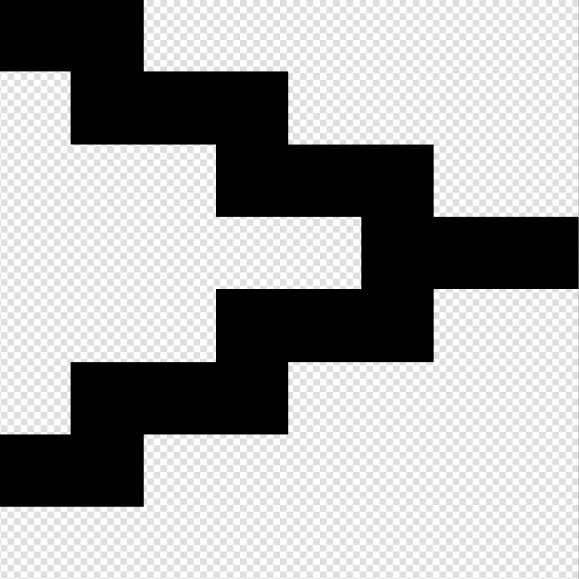

(iv)

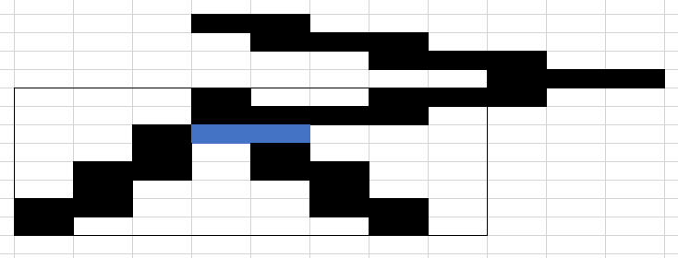

(b)

(i) AABBs (Axis Aligned Bounding Boxes) are used in the intersection test which produces collision islands to be passed on to the narrow phase. This reduces the overall number of tests required which can grow very large (Handshake Problem).

(ii)

X Sort

Object 1 Start: 50

Object 4 Start: 56

Object 3 Start: 58

Object 1 End: 60

Object 3 End: 62

Object 2 Start: 67

Object 4 End: 68

Object 2 End: 73

X Sweep

1

1,4

1,4,3

4,3

4

4,2

2

Null

X Collision

(1,4)

(1,3)/(4,3)

(4,3)

(4,2)

Y Sort

Object 3 Start: 68

Object 3 End: 88

Object 4 Start: 121

Object 1 Start: 127

Object 4 End: 129

Object 2 Start: 135

Object 1 End: 137

Object 2 End: 145

Y Sweep

3

Null

4

4,1

1

1,2

2

Null

Y Collision

(4,1)

(1,2)

Z Sort

Object 4 Start: 182

Object 4 End: 196

Object 2 Start: 198

Object 1 Start: 199

Object 2 End: 200

Object 3 Start: 201

Object 1 End: 203

Object 3 End: 217

Z Sweep

4

Null

2

2,1

1

1,3

3

Null

Z Collision

(2,1)

(1,3)

Conclusion: A collision has not occurred